

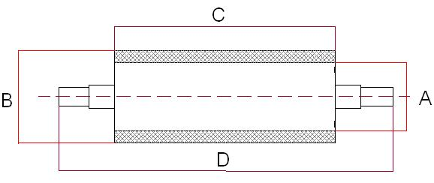

SIZE (in mm.):

A= Ø Core
B= Ø Rubbered core and tolerance: |  | +/- mm
C= Rubbered roller length:
D= Roller length (including axes):

RUBBER FAMILY (FILL ONLY IF KNOWN):

Family (NR, NBR, EPDM, SILICONA, EBONITA, ETC)
Hardness (Sh.A):
Colour preference:

ROLLER USES:
Industrial sector:
Kina of machine and work done:
Machine manufacturer and model:

WORKING SERVICE CONDITIONS:
Working temperature (ºC) | Lowest: |  |  | Highest: |  | Continous:
Chemical agents in contact:

Rotacional speed (r.p.m.:)

Load capacity (Kg/cm²)

Others:

